第七届来华留学人才招聘会学生注册通知

为配合国家“一带一路”倡议，满足用人单位的国际化人才需求，方便来华留学生在华实习、就业与创业，我中心将于2019年10月26日在北京大学举办“第七届来华留学人才招聘会”。
时间：2019年10月26日10:00-16:00
地址：中国北京市颐和园路5号 北京大学新太阳学生中心一层（北京大学南门向北200米）
多家知名企业将为来华留学生提供大量就业、实习、创业岗位。助力来华留学生实现职业梦想！
请按照以下步骤获取入场资格：
步骤1：关注：“留学中国”微信公众号（ID：Istudyinchina）；


步骤2：在微信公众号对话框中输入“1026”，点击链接进入第七届来华留学人才招聘会微站，并填写调查问卷；
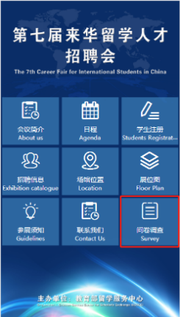
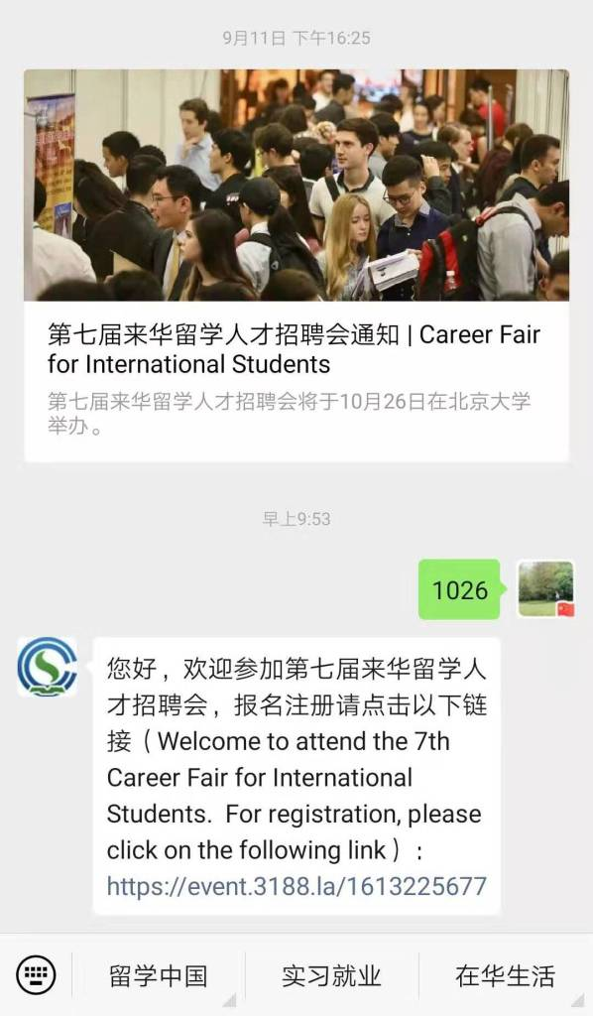

步骤3：在第七届来华留学人才招聘会微站进行注册，注册完成后，您将收到注册成功的邮件，请及时查收并打印邮件；

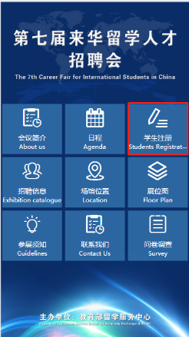
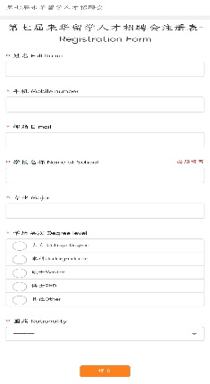
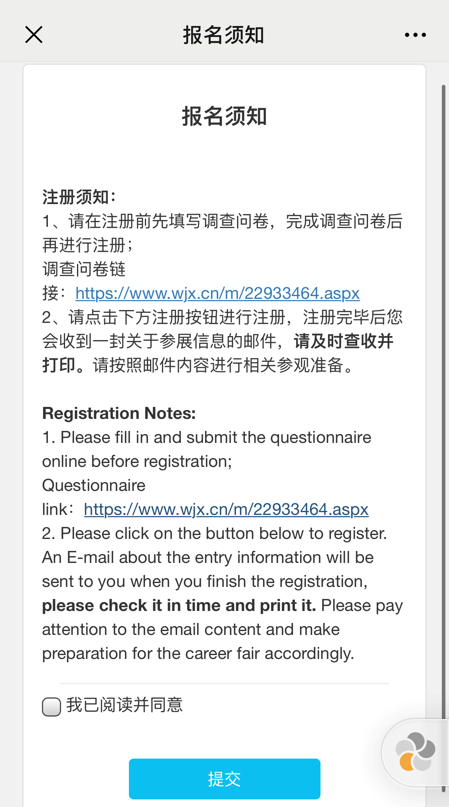
注册成功页面如图所示

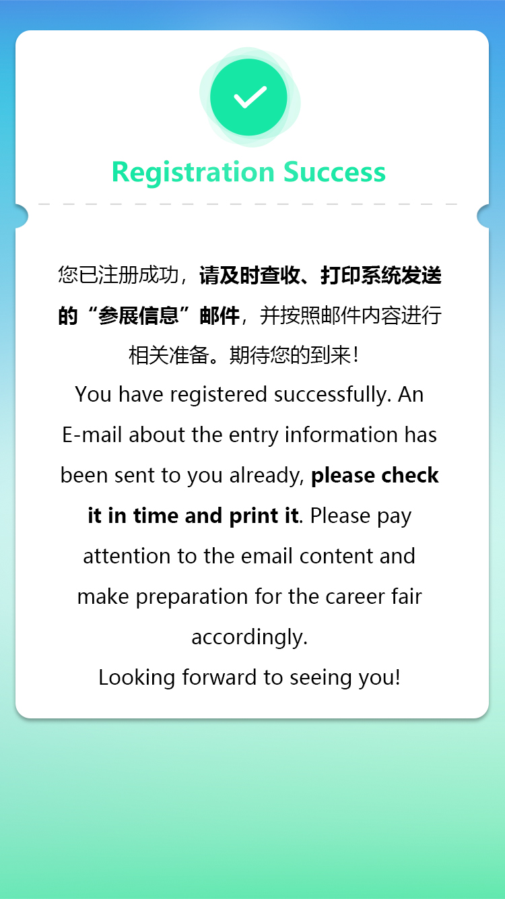

步骤4： 10月26日活动当天，需持打印出的电子邮件(如下图所示），并凭本人护照/学生证免费入场观展。
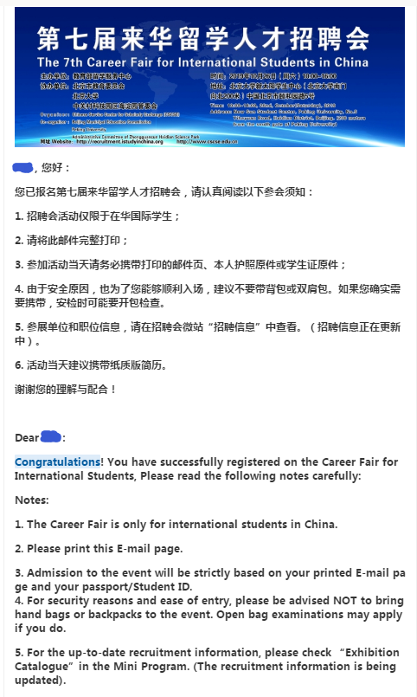

The 7th Career Fair for International Students in China 2019
In order to meet the enterprises’ needs of recruitment and facilitate internships, employment and entrepreneurship for international students in China, the 7th Career Fair for International Students in China is going to be held in Peking.
Date: 26th October, 2019
Time: 10:00---16:00
Place: Peking University
Add. : New Sun Student Center, Peking University (200 meters from the south gate of Peking University)
No.5 Yiheyuan Road, Haidian District, Beijing

Come and join us!
Prestigious enterprises with hundreds of job positions!
Internship and job opportunity before graduation!
Help you achieve your career dream!

Please follow the steps bellow to get your entry qualification:
Step 1: Please follow the WeChat Official Account “Istudyinchina”；

Step 2： Please enter “1026” in the dialog box of the WeChat Official Account to access the Career Fair Mini Program，and fill in the survey;
Step 3： Register in the Career Fair Mini Program. When you finish the registration, an E-mail about the entry information will be sent to you , please check it in time and print it.
This is the confirmation page after you complete your registration successfully.

Step 4: Admissions to the event on 26th October will be strictly based on your printed E-mail page（as follows） and your passport/Student ID.

